Experiment No: Q35
Title
Minimum Path Sum in Triangle Using Dynamic Programming

Aim
To find the minimum path sum from the top to the bottom of a triangle of numbers using Dynamic Programming.

Theory
Given a triangle of numbers, starting from the top element, we can move only to adjacent numbers in the next row.
The objective is to find the minimum possible sum along a path from the top row to the bottom row.
Dynamic Programming is used to store intermediate minimum sums and avoid repeated calculations.
For each element:
$$dp[i][j]=triangle[i][j]+min⁡(dp[i+1][j],dp[i+1][j+1])$$
The solution is obtained at the top element after processing from the bottom row upwards.

Algorithm
- Read the number of rows n.
- Input the triangle elements.
- Copy the last row into a DP array.
- Traverse the triangle from the second-last row upward.
- For each element:
  - Add the minimum of the two adjacent elements from the row below.
- Continue until the top row is reached.
- The top element of the DP array contains the minimum path sum.
- Display the result.

Program
# Minimum Path Sum in Triangle using Dynamic Programming
def minimum_path_sum(triangle, n):
dp = triangle[-1][:]
for i in range(n - 2, -1, -1):
for j in range(i + 1):
dp[j] = triangle[i][j] + min(dp[j], dp[j + 1])
return dp[0]
n = int(input("Enter number of rows: "))
triangle = []
print("Enter the triangle elements:")
for i in range(n):
row = list(map(int, input().split()))
triangle.append(row)
result = minimum_path_sum(triangle, n)
print("\nMin Sum =", result)

Sample Input
Enter number of rows: 3
Enter the triangle elements:
2
3 4
6 5 7

Output
Min Sum = 10

Observation
Triangle
2
3 4
6 5 7
Possible Paths:
2 → 3 → 6 = 11
2 → 3 → 5 = 10
2 → 4 → 5 = 11
2 → 4 → 7 = 13
Minimum Path:
2 → 3 → 5
Minimum Sum:
10
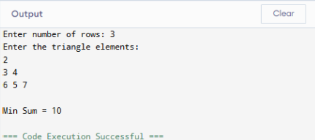

Analysis
- Dynamic Programming computes the minimum path efficiently.
- Each element is processed only once.
- Bottom-up computation avoids recursion overhead.
- Suitable for large triangles.
Time Complexity
O(n²)
Space Complexity
O(n)
where n is the number of rows in the triangle.

Conclusion
The Minimum Path Sum in Triangle problem was successfully solved using Dynamic Programming. By processing the triangle from bottom to top, the algorithm efficiently computes the minimum path sum. The method reduces redundant calculations and provides an optimal solution with O(n²) time complexity and O(n) space complexity.

